CASINO USER

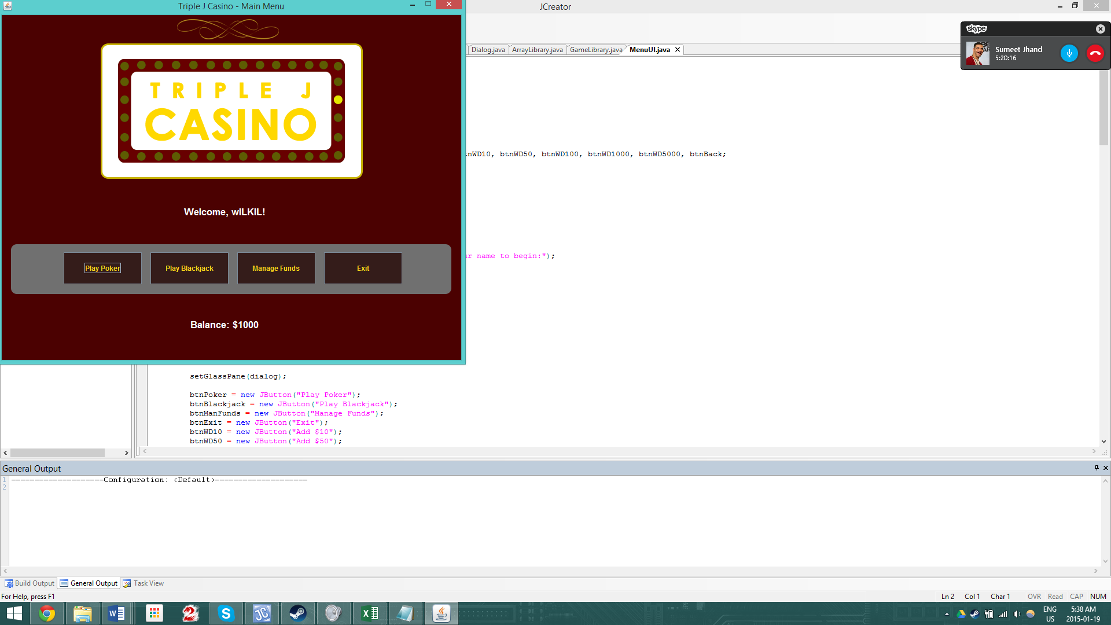MANUAL

Note: This Manual does not explain how to play Blackjack and Poker, instead it explains how to use the user interface

Welcome to Triple J Casino. This is a virtual casino where you can play games such as Poker and Black Jack!

**MAIN MENU**

Step 1 (LOG IN): Upon start up you will be prompted by the following box:

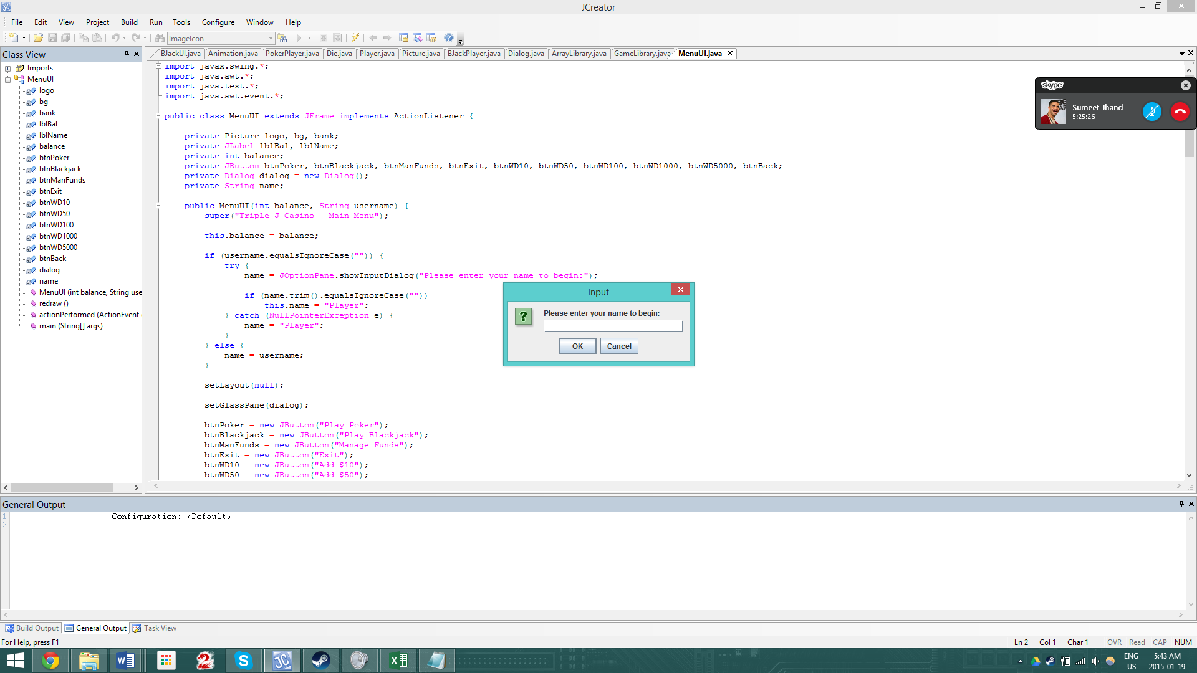

Just simply enter your username here to begin

Step 2 (Main Menu): Upon entering your username you will be brought to the following screen

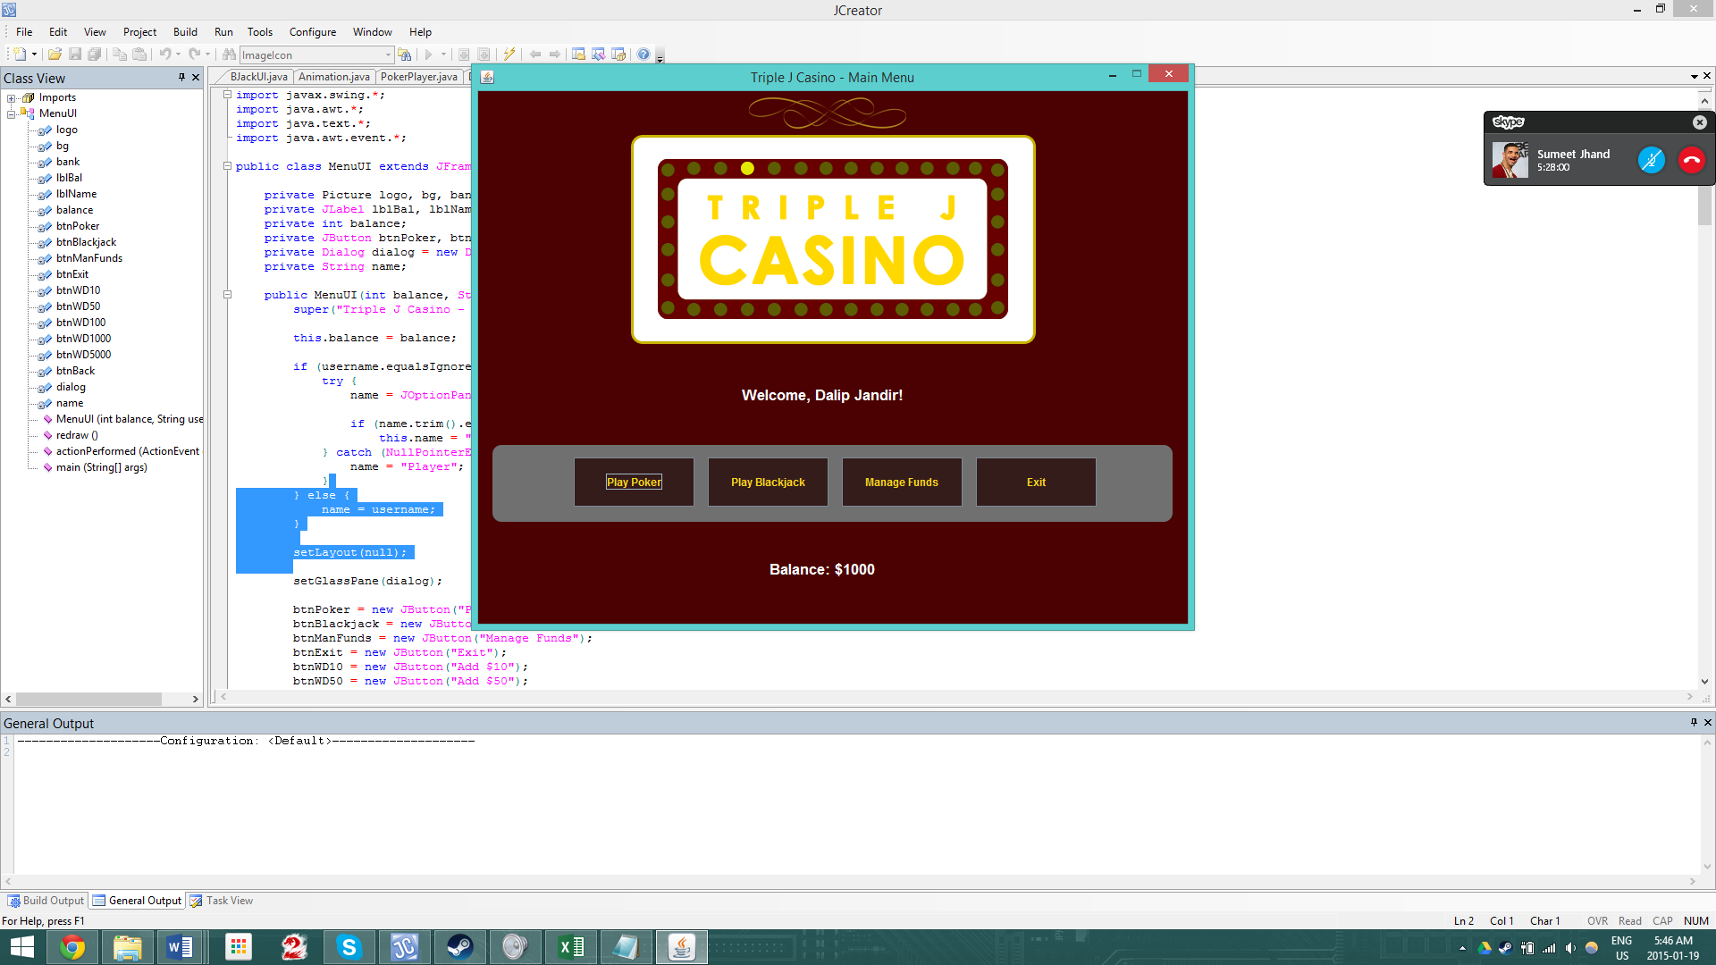

PLAY POKER: Allows you to go and play against 3 AI. NOTE: You must have a minimum balance of $500 to play!

PLAY BLACKJACK: Allows you to play blackjack against a dealer NOTE: You must have a minimum balance of $5 to play

EXIT: Allows you to exit the program

MANAGE FUNDS: Allows you to add funds to the game

Step 3 (Manage Funds): Upon pressing the manage funds button you will be brought to the following screen

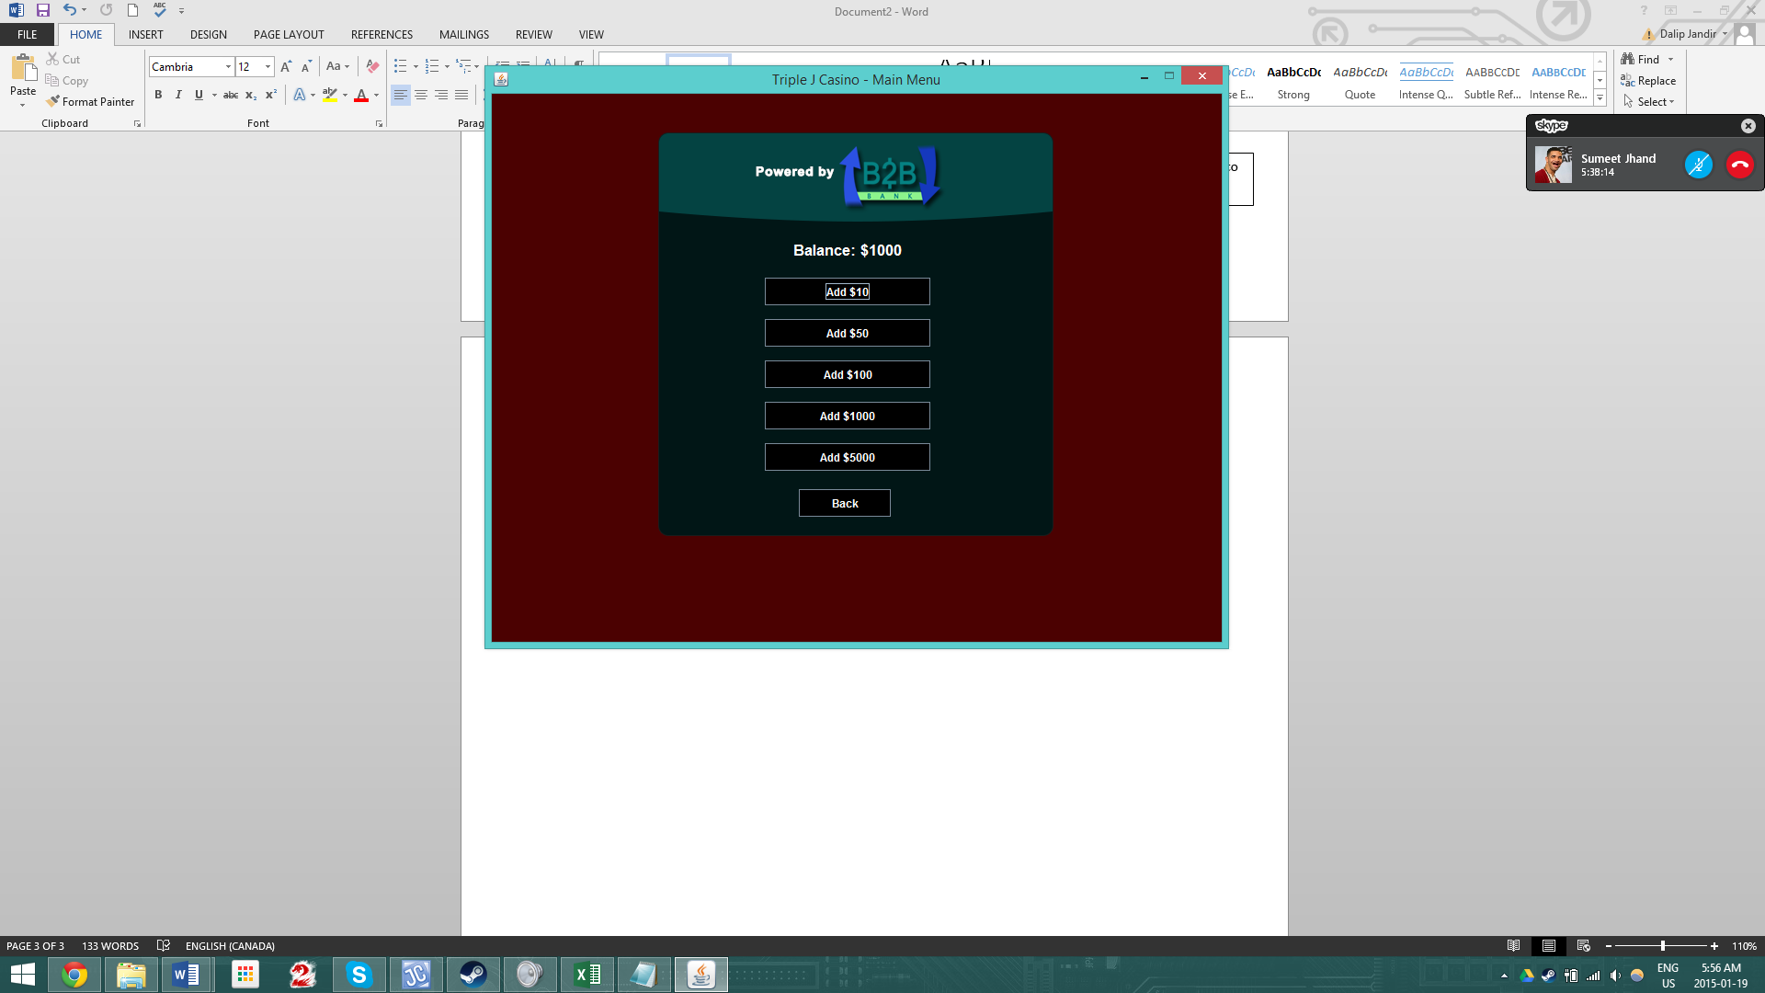

Here you can simply add funds by pressing any of the buttons to do so.

POKER

POKER SCREEN: Upon pressing the “Play Poker” button you will land on the following screen

Yellow box shows the current players turn

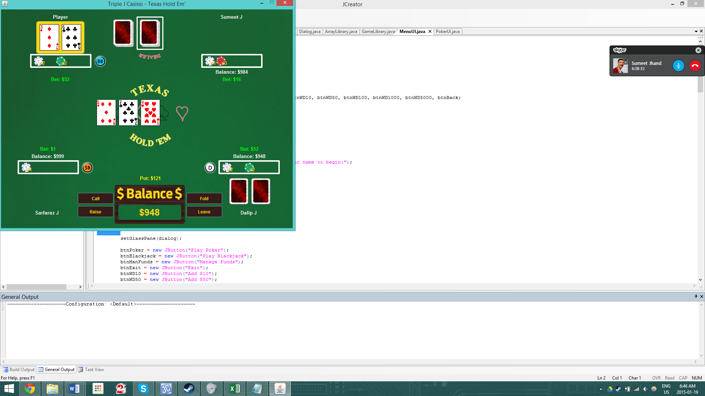

Screen Explained:

PLAYER MENU:

CALL: Press this to call or check to current amount

FOLD: Press this to fold your cards



Raise: Upon pressing this an input box will show up that will let you raise to a custom amount

LEAVE: Upon pressing this you will be returned to the main menu

This shows what the pot is currently at

This shows your current balance.

PLAYER / AI DISPLAY:

This will shows the AI Balance



This shows the yours / AI’s current bet

This shows a visual version of the bet

Player name

AI’s cards will be shown upside down, yours will be show right side up

DEALER DISPLAY:



Trash pile

Everyone’s cards

Deck

BLACKJACK

BLACKJACK MENU SCREEN: Upon pressing the “Play Poker” button you will land on the following screen. This is also the screen you will see at the beginning of every round

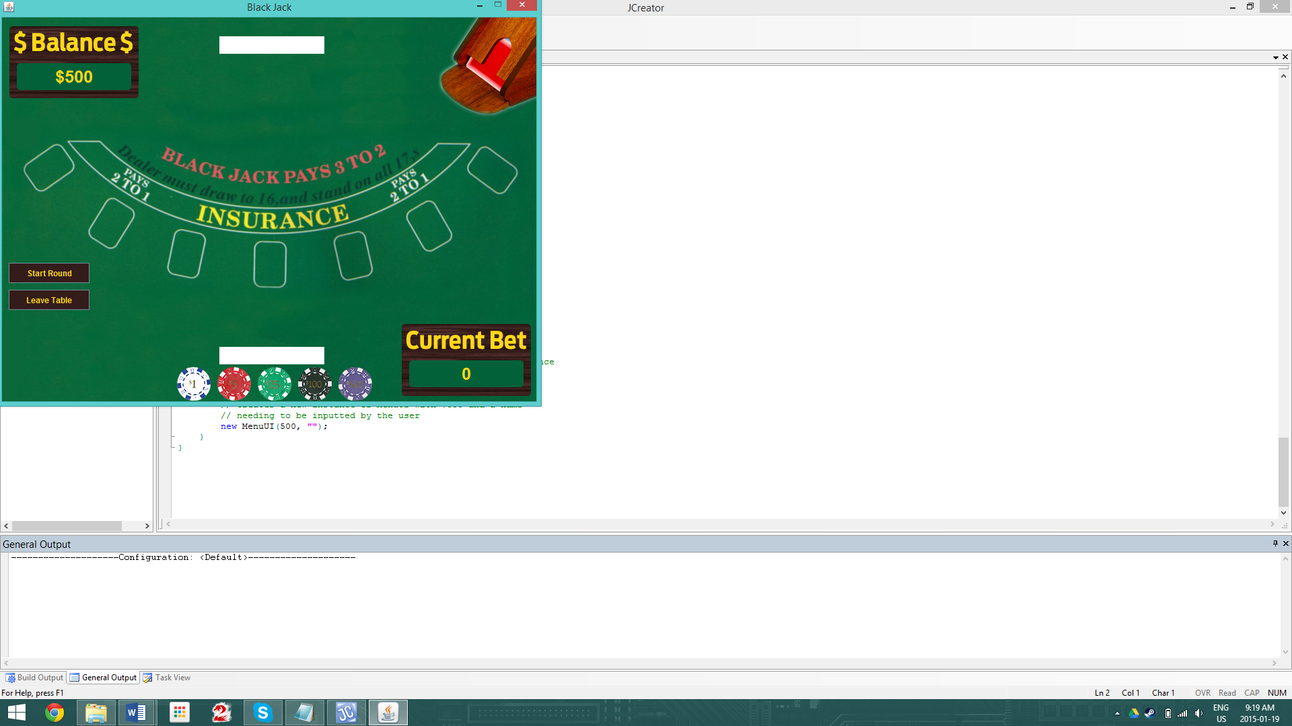

CHIPS BUTTONS: Press these to add onto your bet

Displays your current bet

LEAVE TABLE: Press this to leave the table and go back to the main menu

START ROUND: Press this to begin the round after you are satisfied with your bet

Your balance will be displayed here

BLACKJACK GAMEPLAY SCREEN: This is the screen you’ll see when you press the start round button

Displays dealer’s card total

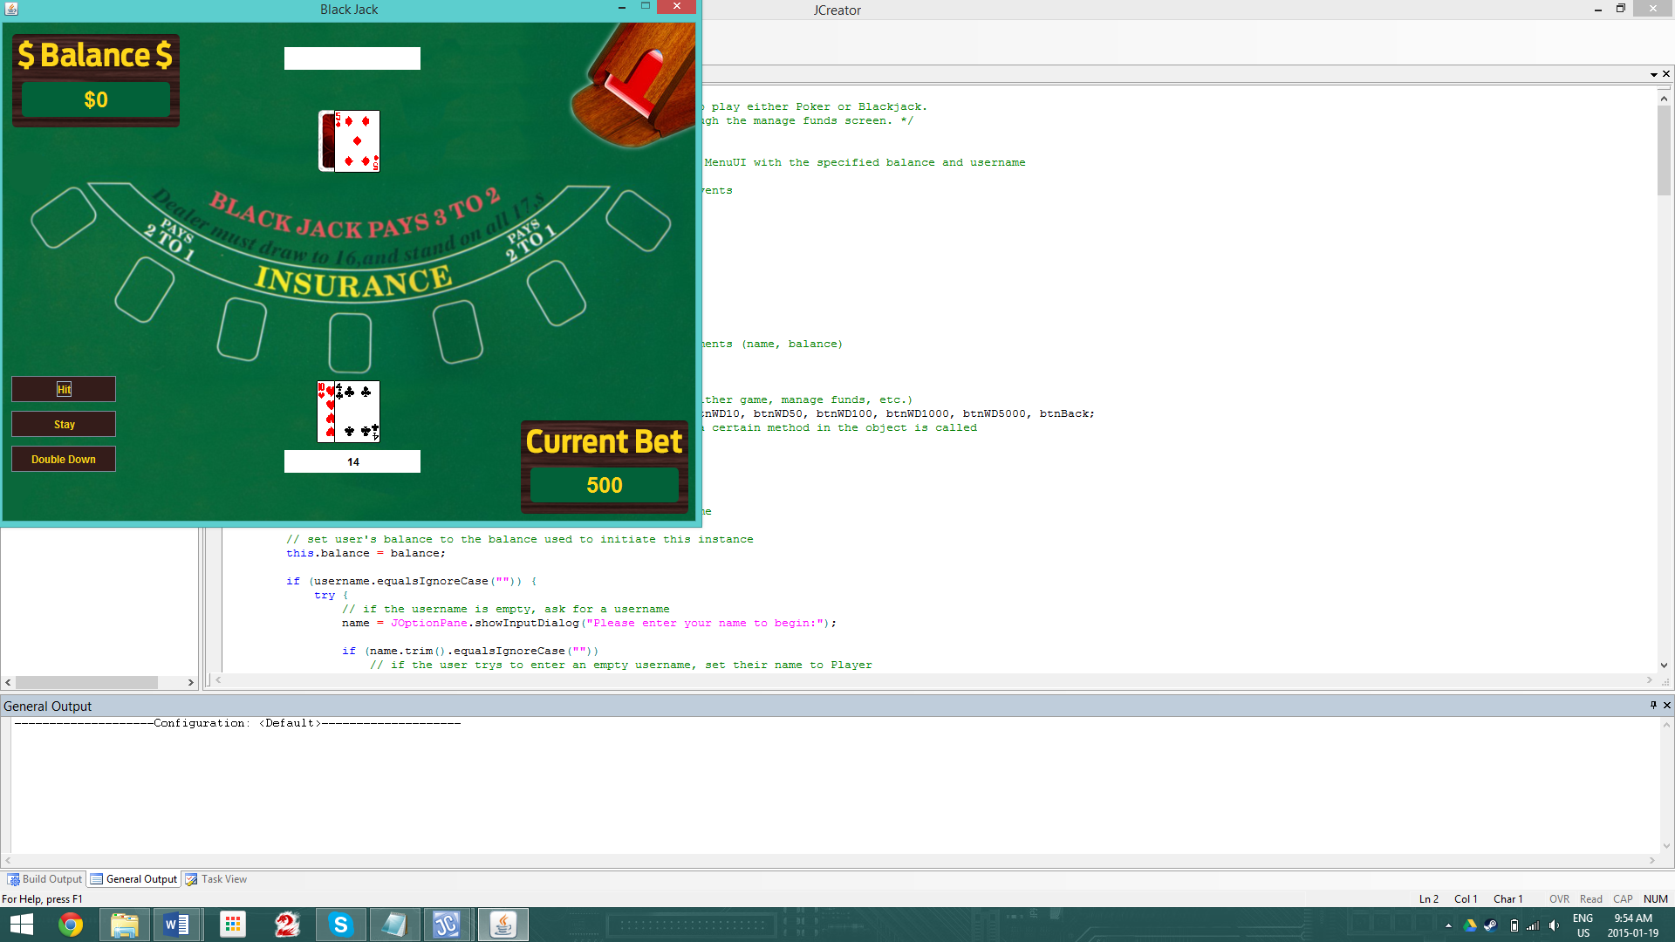

Displays player’s card total

HIT: Draw a card

STAY: End your turn

DOUBLE DOWN: Draw a card, double your bet, and end your turn

That is how to use the UI, enjoy playing on Triple J Casino!